Components: Muscular System  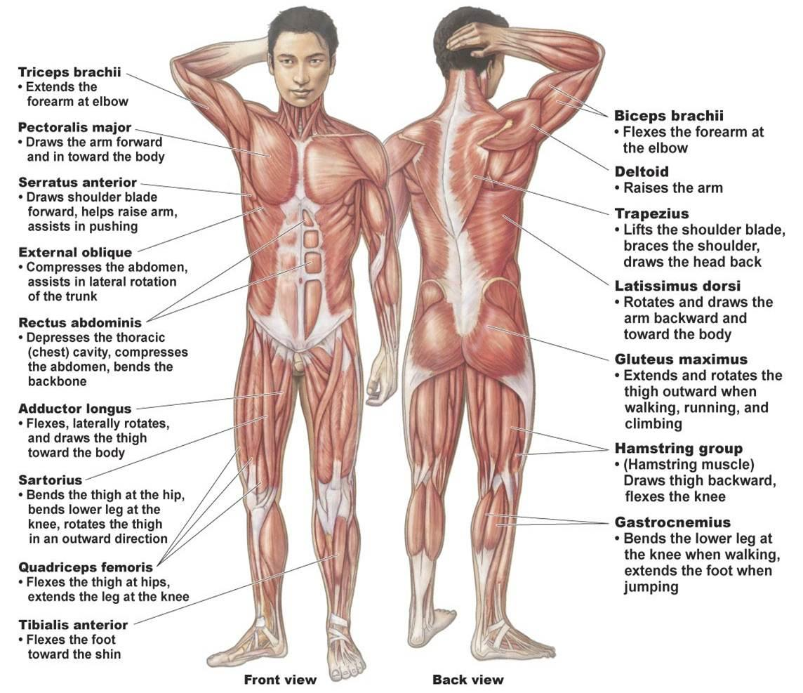 | Functions: Muscular System  *  *  *  *
Interactions: Muscular System  *  *  * | Malfunctions: Muscular System  Injury: Strain  Symptoms: Depends on the grade. Grade I: pain and swelling. Grade II: pain, swelling, and weakness. Grade III: pain, weakness, and loss of function  Treatment: Depends on the grade. Grade I and II: RICE…rest, ice, compression with bandage, elevate. Grade III: immobilize injured muscle or surgery  Prevention: warm up and stretch before and after sport activities, lift heavy objects with correct posture, exercise gradually building on intensity  Inherited Disease: Muscular Dystrophy  Symptoms: progressive weakening of specific muscles  Treatment: physical therapy, medication, and surgeries can help  Prevention: no prevention, inherited, no cure

