Muscular System
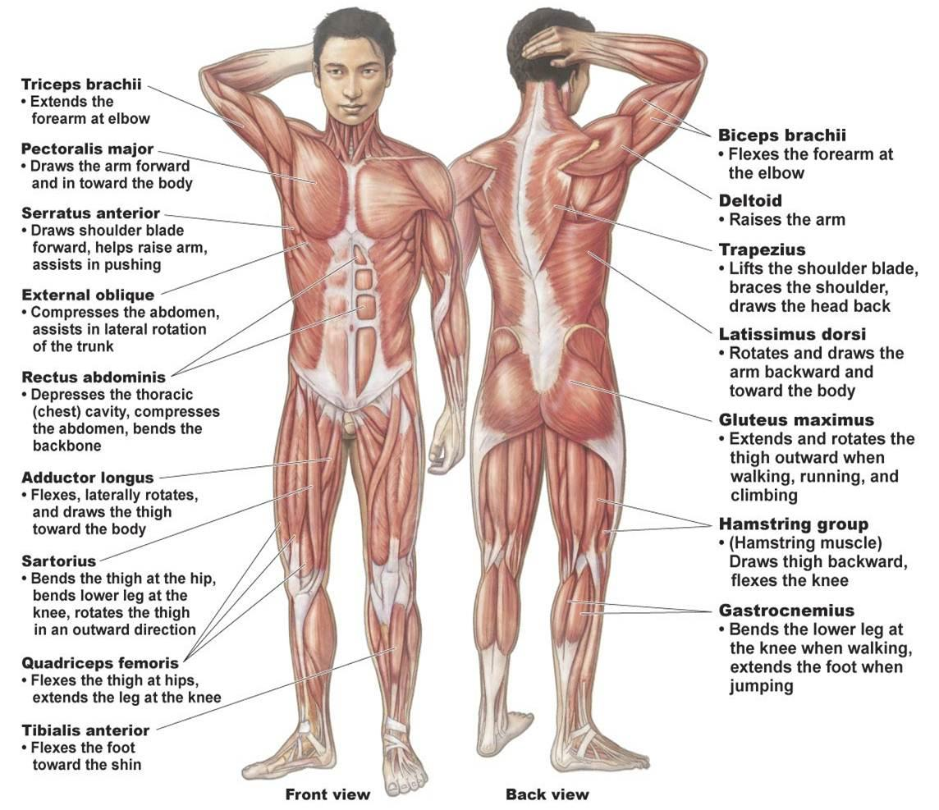
Pick two anterior muscles. Write examples of how you use them in basketball.

Pick two posterior muscles. Write an analogy to explain the movement of those muscles.

Location Terms | Description of Location
Anterior | Towards the front of the body (abdomen/chest are anterior to the back)
Posterior | Towards the back of the body (back is posterior to the abdomen/chest)
Ventral | Towards the front of the torso (on the front of the body)
Dorsal | Towards the back of the torso (on the back of the body)
Medial | Towards the center or midline of the body (the sternum is medial to the shoulder).
Lateral | Away from the midline of the body – to the side (the shoulder is lateral to the sternum).
Inferior (Caudal) | Below – in relation to another structure (feet are inferior to knees)
Superior (Cranial) | Above – in relation to another structure (knees are superior to feet)
Proximal | Nearest the trunk or point of origin of the limb (shoulders are proximal to elbows)
Distal | Situated away from the center or midline of the body or away from the point of origin, closer to the end of the limbs (the hand is distal).
Contralateral | Pertaining or relating to the opposite side.
Ipsilateral | On the same side
Transverse | Horizontally across the body

Movements | Description | Examples
Flexion | Decreasing the inner angle of the joint | Bending the elbow  Dropping the chin to the chest  Folding forward (flexion of spine)
Extension | Increasing the inner angle of the joint | Back bend  Kicking leg back (hip extension)
Abduction | Moving away from the midline of the body | Lifting leg to the side  Lifting arms up from sides into T position
Adduction | Moving towards the midline of the body | Crossing one leg in front of the other  Crossing arm in front of torso or behind back
Lateral Flexion | Sidebending (neck/torso) | Dropping ear towards shoulder, Crescent Stretch (dropping one hand down same side of body)
Rotation | Rotating or pivoting around a long axis | Twisting along spinal column (seated twist)  Turning palms up and down
Circumduction | Circular movement | Arm circles
Dorsiflexion | Flexing the ankle with foot moving upwards | Lifting toes up towards body
Plantarflexion | Flexing the ankle with foot moving downward | Pointing toes
Pronation | Rotating the forearm with the palm turning inward | Lifting arm then turning arm (like emptying a can of soda)
Supination | Rotating the forearm with the palm turning outward | Lifting arm then turning arm back (turning palms towards ceiling)
Inversion | Turning sole of foot medially (inward) | Turning feet in, turning toes towards each other
Eversion | Turing sole of foot laterally outward | Turning feet out, bringing backs of heels towards each other.
Horizontal Abduction | Move arm in horizontal plane away from the body | Bring arms to shoulder height and pull arms back (opening through chest)
Horizontal Adduction | Moving arm in horizontal plane inwards across body | Crossing arms in front of the chest
Protraction | Draw forward (shoulder) | Round shoulders forward “spreading” back
Retraction | Draw back (shoulders) | Squeezing shoulder blades together
- ________ is a muscle that originates on the surface of the 1st to 8th ribs at the side of the chest and inserts along the entire anterior length of the medial border of the scapula.
- _________ is a muscle located lateral to the pectoralis major, anterior border of the clavicle and posterior from the scapula.
- ______is an anterior muscle, medial to the thigh, inferior to the torso, and contains four muscles.
- ______is a posterior, ipsilateral and inferior to the torso muscle.

Answers:
- Serratus Anterior
- Deltoid
- Quadraceps Femoris
- Gluteus Maximus

You try!
Write the location of two different muscles.

