Skeletal System: Components  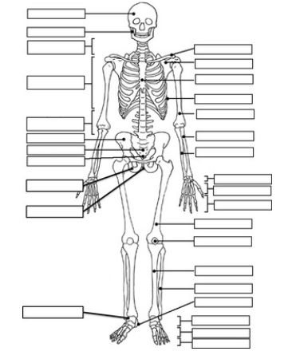 | Skeletal System: Function  Support:  Protects:  Movement:  Blood Formation:  Electrolyte Balance:  Acid Base Balance:
Skeletal System: Interactions with other Systems  Circulatory System:  Muscle System:  Digestive System:  Marrow: | Skeletal System: Malfunctions  Scoliosis:  - Symptoms:  - Treatment:  - VEPTR

